Project #2 – Musa Harshuk

**Introduction:**

The analysis has been done about improving the knowledge we know about the company's

Products and getting conclusion from the data we have .

The question that was asked were revolving around the company's financial term mostly and how to improve our income and products usage :

**Question #1:**

* **What are the characteristics of our biggest customers?**

This question was asked to check if we have a certain kind of customer and to manipulate our products for their cause to improve the sales and income ,the conclusion was that we don’t have enough data about of customers and we have only the location they live in , the recommendation Is to improve data collection about the customer to be able to improve the products based on that.

**Question #2:**

* **What is our most popular product and which product is give us the most income**
* **And to which category they are from?**

In order to select the best products for the company we have to identify

The most popular

The most money making

And to which category they are from.

The conclusion are that we have a very specific type of shoe that preforms best in both popular and most profitable and it’s the sneakers products, we recommend that we drop lower preforming categories and invest the money into the most preforming products, but we can also see that we have non standard deviation and our company has very bug products alongside very poor products we will need to re check and reset our marketing plan.

Example for low preforming category of products :

'Slippers' ,'flats', 'heels'.

**Question 3#:**

* **In which states do we have the most success with our products?**

This question gives us the location of our best preforming areas for our company, the conclusion is that the eastern state preforms better that all the other areas and bring un more income .

**Question #4:**

* **Which manufacturer bring the most sales to the company?**

The question will give us indication of which business partners

We should keep and who we should drop, in conclusion most of our top preforming manufactures are not in the most demanding manufactures the mean we have a lot of money paid to manufactures to create an product that doesn’t sell ,we shall consider changing these demanding and not preforming manufacturers.

Manufacturers like :

New Balance

Radii Footwear

Timberland

Sebago

Reebok

Psyberia

Are charging us most of the money and are not preforming.

**Body:**

the data we used is the Ds Six Data set it’s 12 tables that includes data about our company.

The application that were used are 'SQL' and 'tableau'.

**The steps we took:**

First of all we started analyzing the table that we needed to use

In order the be aware which data I have and what do I wan to get out of it

Then we asked our questions to specify our analysis route

**The questions –**

* **What are the characteristics of our biggest customers**

We wanted to know more about our customers and we got only their location

And we have found out that the customer that are buying the most are from the east coast and this is the only data we have about them and it’s a problem.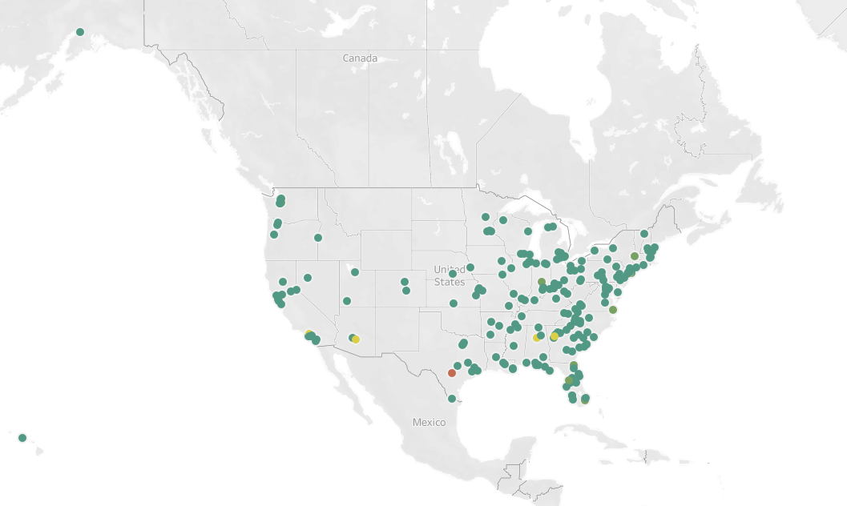

**What is our most popular product and which product is give us the most income**

**And to which category they are from.**

In order to get the best out of our output we need to know where we are best at

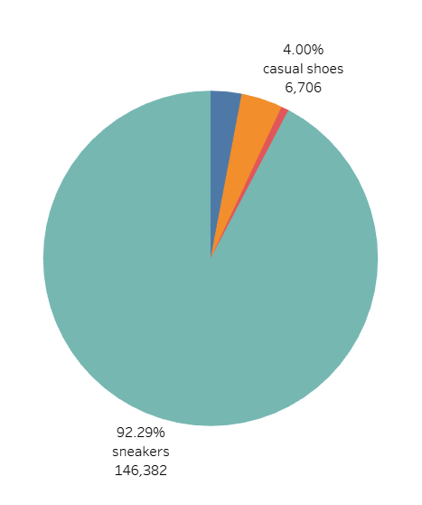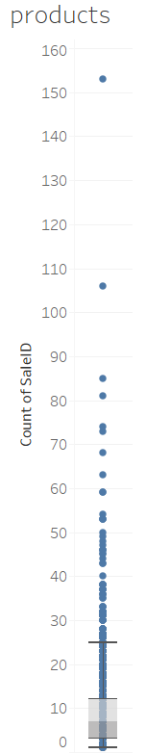That’s the reason we check the most popular product and the most profitable and to which category they are belong .

The best preforming products categories

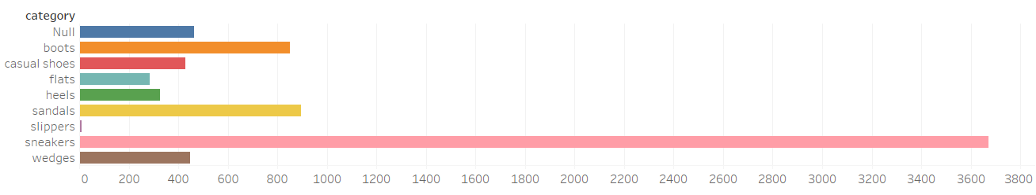

**In which states do we have the most success with our products?**

We wanted to know after we looked for the WHO &WHAT

We needed to know WHERE does our company preform the best

Country wise and state wise.

We group the state this way so we can have groups to relate to

And we got the result that the east coast has the greatest number of sales from us

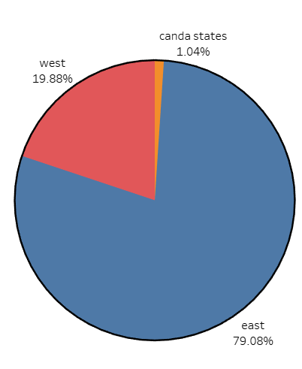

**Which manufacturer bring the most sales to the company ?**

This question was the point were we needed to know from where our best preforming and least preforming products come from

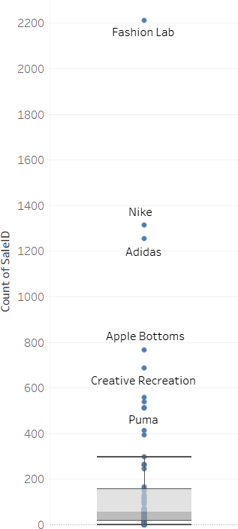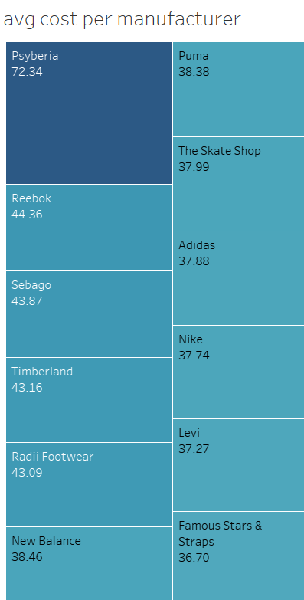We have checked the manufacturers in various approaches

Here we can see that we have a really big difference between our manufactures

We have some top performers and very poorly preforming ones

Here you can see that we have certain companies that charge us more than the most preforming companies and that should be taking into consideration

As you can see the most charging companies are the poorest performing in the group of the most preforming product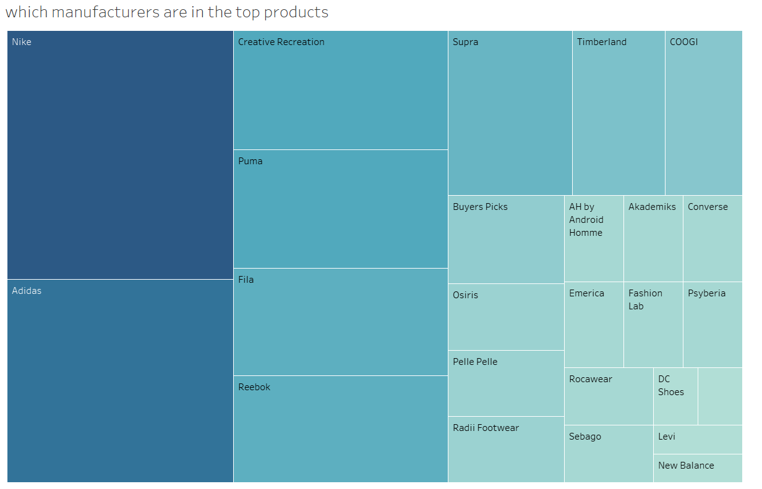

Conclusions:

After the analysis we can clearly see that we have were to develop,

For start we need to get more data about our customer to improve our service and products.

we can see in the product area we have very polar product performance , majority of our products doesn’t perform well we need to address that and improve it for instance to drop

products that have poor performance , on the other hand we have products that are doing very good and there should be a consideration about investing more in those kinds of products for example snickers who has the best performance in the company.

Example for low preforming category of products :

'Slippers' ,'flats', 'heels'.

The conclusion about the state and the areas that we have more customer on the eastern side on the US and we need to develop there more other than that we have very little customers in Canada ,and we need to consider expanding there more

The analysis about the manufacturers show us that we are purchasing products in high price that are preforming poorly we recommend to get rid of the high charging and low preforming companies and invest more on the higher preforming companies.

Manufacturers like :

New Balance

Radii Footwear

Timberland

Sebago

Reebok

Psyberia

Are charging us most of the money and are not preforming.